Part of a Whole Number
# Source: AI Source: Provided by: [Data Path: Persons Table -> ID Column: 1, Name_En Column: Motasem Essam] -> From: [ChatGPT] on [7/11/2026]
A part of a whole represents a quantity that is less than or equal to one complete unit. In mathematics, parts of a whole are commonly expressed using fractions, decimals, and percentages. Although these forms look different, they can represent the same value and can be converted from one form to another.
Understanding these representations is essential for arithmetic, measurement, finance, probability, statistics, and many everyday applications.

Definition
# Source: AI Source: Provided by: [Data Path: Persons Table -> ID Column: 1, Name_En Column: Motasem Essam] -> From: [ChatGPT] on [7/11/2026]
A part of a whole is a portion or fraction of a complete object, collection, or quantity.
The three most common ways to represent a part of a whole are:
- Fraction – expresses a part as a ratio of two integers.
- Decimal – expresses a part using the base-10 place value system.
- Percentage – expresses a part as a number out of 100.

1. Fraction
# Source: AI Source: Provided by: [Data Path: Persons Table -> ID Column: 1, Name_En Column: Motasem Essam] -> From: [ChatGPT] on [7/11/2026]
A fraction represents one or more equal parts of a whole.

Definition
# Source: AI Source: Provided by: [Data Path: Persons Table -> ID Column: 1, Name_En Column: Motasem Essam] -> From: [ChatGPT] on [7/11/2026]
A fraction has the form
a/b​

where:
- a = numerator (number of parts taken)
- b = denominator (total equal parts), with b≠0

Example
# Source: AI Source: Provided by: [Data Path: Persons Table -> ID Column: 1, Name_En Column: Motasem Essam] -> From: [ChatGPT] on [7/11/2026]
If a pizza is divided into 8 equal slices and you eat 3 slices:
3/8
You have eaten three out of eight equal parts.

Main Types of Fractions

1. Proper Fraction
# Source: AI Source: Provided by: [Data Path: Persons Table -> ID Column: 1, Name_En Column: Motasem Essam] -> From: [ChatGPT] on [7/11/2026]
A proper fraction is a fraction whose numerator is less than its denominator.
Mathematically:
$$a<b$$
Examples:
$$\frac{1}{2}, \frac{3}{5}, \frac{7}{10}$$
Properties:
- Value is greater than 0 and less than 1
- Represents less than one whole

2. Improper Fraction
# Source: AI Source: Provided by: [Data Path: Persons Table -> ID Column: 1, Name_En Column: Motasem Essam] -> From: [ChatGPT] on [7/11/2026]
An improper fraction has a numerator greater than or equal to its denominator.
Mathematically:
$$a≥b$$
Examples:
$$\frac{5}{4}, \frac{9}{7}, \frac{8}{8}$$
Properties:
- Value is greater than or equal to 1
- Can be written as a mixed number (except when equal to a whole number)

3. Mixed Fraction (Mixed Number)
# Source: AI Source: Provided by: [Data Path: Persons Table -> ID Column: 1, Name_En Column: Motasem Essam] -> From: [ChatGPT] on [7/11/2026]
A mixed fraction consists of a whole number and a proper fraction.
General form:
$$a\frac{b}{c}$$
Examples:
$$2\frac{1}{3},5\frac{4}{7}$$
Conversion Example:
$$\frac{11}{4}=2\frac{3}{4}$$
Properties:
- Represents a quantity greater than one
- Can always be converted to an improper fraction

4. Unit Fraction
# Source: AI Source: Provided by: [Data Path: Persons Table -> ID Column: 1, Name_En Column: Motasem Essam] -> From: [ChatGPT] on [7/11/2026]
A unit fraction has a numerator equal to 1.
Mathematically:
$$\frac{1}{n}$$
Examples:
$$\frac{1}{2}, \frac{1}{5}, \frac{1}{100}$$
Properties:
- Represents one equal part of a whole
- The denominator determines the size of the part

5. Non-Unit Fraction
# Source: AI Source: Provided by: [Data Path: Persons Table -> ID Column: 1, Name_En Column: Motasem Essam] -> From: [ChatGPT] on [7/11/2026]
A non-unit fraction has a numerator greater than 1.
Examples:
$$\frac{2}{5}, \frac{3}{7}, \frac{11}{20}$$
Properties:
- Represents multiple equal parts of a whole

6. Equivalent Fractions
# Source: AI Source: Provided by: [Data Path: Persons Table -> ID Column: 1, Name_En Column: Motasem Essam] -> From: [ChatGPT] on [7/11/2026]
Equivalent fractions represent the same value even though their numerators and denominators are different.
Examples:
$$\frac{1}{2}=\frac{2}{4}=\frac{3}{6}=\frac{4}{8}$$
Properties:
- Obtained by multiplying or dividing the numerator and denominator by the same nonzero number.
- Represent exactly the same quantity.

7. Like Fractions
# Source: AI Source: Provided by: [Data Path: Persons Table -> ID Column: 1, Name_En Column: Motasem Essam] -> From: [ChatGPT] on [7/11/2026]
Like fractions have the same denominator.
Examples:
$$\frac{1}{8}, \frac{3}{8}, \frac{5}{8}, \frac{7}{8}$$
Properties:
- Easy to compare and add or subtract

8. Unlike Fractions
# Source: AI Source: Provided by: [Data Path: Persons Table -> ID Column: 1, Name_En Column: Motasem Essam] -> From: [ChatGPT] on [7/11/2026]
Unlike fractions have different denominators.
Examples:
$$\frac{1}{3}, \frac{2}{5}, \frac{7}{8}$$
Properties:
- Must usually be converted to like fractions before adding or subtracting

9. Decimal Fraction
# Source: AI Source: Provided by: [Data Path: Persons Table -> ID Column: 1, Name_En Column: Motasem Essam] -> From: [ChatGPT] on [7/11/2026]
A decimal fraction has a denominator that is a power of 10.
Mathematically:
$$10, 100, 1000, 10000,…$$
Examples:
$$\frac{7}{10},\frac{35}{100},\frac{421}{1000}$$
Equivalent decimals:
$$\frac{3}{5}=\frac{60}{100}=0.60$$
Properties:
- Easily written in decimal form

10. Complex Fraction
# Source: AI Source: Provided by: [Data Path: Persons Table -> ID Column: 1, Name_En Column: Motasem Essam] -> From: [ChatGPT] on [7/11/2026]
A complex fraction is a fraction in which the numerator, denominator, or both contain fractions.
Examples:
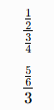
$$\frac{\frac{1}{2}}{\frac{3}{4}}$$
$$\frac{\frac{5}{6}}{3}$$

Properties:
- Simplified by dividing the numerator by the denominator

11. Simple Fraction
# Source: AI Source: Provided by: [Data Path: Persons Table -> ID Column: 1, Name_En Column: Motasem Essam] -> From: [ChatGPT] on [7/11/2026]
A simple fraction has whole numbers as both its numerator and denominator.
Examples:
$$\frac{4}{7}, \frac{8}{9}, \frac{3}{5}$$
Properties:
- Most common type of fraction
- Opposite of a complex fraction

Summary Table
# Source: AI Source: Provided by: [Data Path: Persons Table -> ID Column: 1, Name_En Column: Motasem Essam] -> From: [ChatGPT] on [7/11/2026]
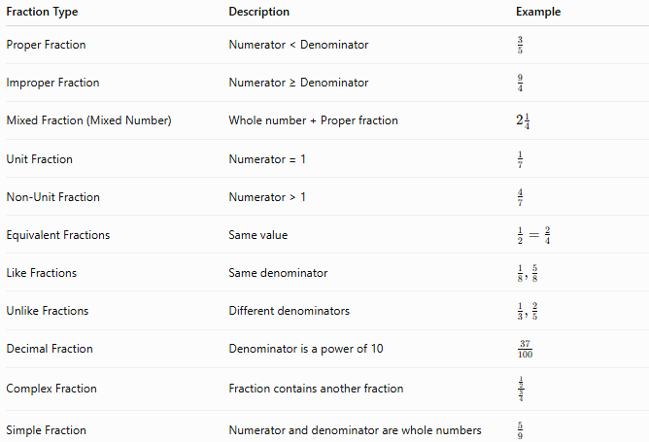
Fraction Type | Description | Example
Proper Fraction | Numerator < Denominator | $$\frac{3}{5}$$
Improper Fraction | Numerator ≥ Denominator | $$\frac{9}{4}$$
Mixed Fraction (Mixed Number) | Whole number + Proper fraction | $$2\frac{1}{4}$$
Unit Fraction | Numerator = 1 | $$\frac{1}{7}$$
Non-Unit Fraction | Numerator > 1 | $$\frac{4}{7}$$
Equivalent Fractions | Same value | $$\frac{1}{2}=\frac{2}{4}$$
Like Fractions | Same denominator | $$\frac{1}{8},\frac{5}{8}$$
Unlike Fractions | Different denominators | $$\frac{1}{3},\frac{2}{5}$$
Decimal Fraction | Denominator is a power of 10 | $$\frac{37}{100}$$
Complex Fraction | Fraction contains another fraction | $$\frac{\frac{1}{2}}{\frac{3}{4}}$$
Simple Fraction | Numerator and denominator are whole numbers | $$\frac{5}{9}$$

Real-Life Applications
# Source: AI Source: Provided by: [Data Path: Persons Table -> ID Column: 1, Name_En Column: Motasem Essam] -> From: [ChatGPT] on [7/11/2026]
Different types of fractions are used in:
- Sharing food equally
- Measuring ingredients in recipes
- Construction and engineering
- Money and finance
- Probability
- Statistics
- Scientific measurements
- Education

Real-Life Examples
# Source: AI Source: Provided by: [Data Path: Persons Table -> ID Column: 1, Name_En Column: Motasem Essam] -> From: [ChatGPT] on [7/11/2026]
1. Proper Fraction
A pizza is divided into 8 slices.
Ahmed eats 3 slices.
Fraction eaten:
$$\frac{3}{8}$$

2. Improper Fraction
A baker uses 9 half-cups of flour.
This is:
$$\frac{9}{2}=4\frac{1}{2}$$
cups.

3. Mixed Fraction
A runner completes:
$$3\frac{1}{2}$$
kilometers.

4. Unit Fraction
One slice from a cake divided into 10 equal slices is:
$$\frac{1}{10}$$

5. Equivalent Fractions
Half of a chocolate bar can be written as:
$$\frac{1}{2}=\frac{2}{4}=\frac{3}{6}$$

6. Like Fractions
Sara drinks:
$$\frac{3}{8}$$
of a bottle in the morning and
$$\frac{2}{8}$$
in the afternoon.
The denominators are the same.

7. Unlike Fractions
A recipe requires:
$$\frac{1}{2}$$
cup of sugar and
$$\frac{1}{3}$$
cup of milk.
The denominators are different.

8. Decimal Fraction
A test score of:
$$\frac{85}{100}$$
can also be written as:
$$0.85$$
or
$$85\%$$

Common Mistakes
# Source: AI Source: Provided by: [Data Path: Persons Table -> ID Column: 1, Name_En Column: Motasem Essam] -> From: [ChatGPT] on [7/11/2026]
- Confusing proper and improper fractions.
- Thinking all improper fractions are mixed numbers.
- Forgetting that equivalent fractions represent the same value.
- Assuming like fractions have the same numerator instead of the same denominator.
- Confusing decimal fractions with decimal numbers.

Key Points
# Source: AI Source: Provided by: [Data Path: Persons Table -> ID Column: 1, Name_En Column: Motasem Essam] -> From: [ChatGPT] on [7/11/2026]
- Fractions are classified according to their structure and value.
- Proper fractions are less than 1.
- Improper fractions are greater than or equal to 1.
- Mixed numbers combine whole numbers and proper fractions.
- Unit fractions have numerator 1.
- Equivalent fractions have the same value.
- Like fractions have the same denominator.
- Unlike fractions have different denominators.
- Decimal fractions have denominators that are powers of 10.
- Complex fractions contain fractions within fractions.

Comparison of Fraction Types
# Source: AI Source: Provided by: [Data Path: Persons Table -> ID Column: 1, Name_En Column: Motasem Essam] -> From: [ChatGPT] on [7/11/2026]
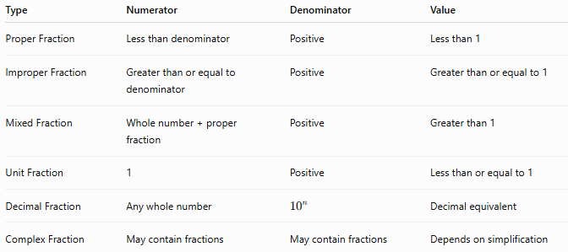
Type | Numerator | Denominator | Value
Proper Fraction | Less than denominator | Positive | Less than 1
Improper Fraction | Greater than or equal to denominator | Positive | Greater than or equal to 1
Mixed Fraction | Whole number + proper fraction | Positive | Greater than 1
Unit Fraction | 1 | Positive | Less than or equal to 1
Decimal Fraction | Any whole number | $${10}^{n}$$ | Decimal equivalent
Complex Fraction | May contain fractions | May contain fractions | Depends on simplification

Conclusion
# Source: AI Source: Provided by: [Data Path: Persons Table -> ID Column: 1, Name_En Column: Motasem Essam] -> From: [ChatGPT] on [7/11/2026]
Fractions can be classified into several types based on their numerators, denominators, or mathematical form. The main types include proper fractions, improper fractions, mixed fractions, unit fractions, non-unit fractions, equivalent fractions, like fractions, unlike fractions, decimal fractions, simple fractions, and complex fractions. Understanding these types provides the foundation for performing fraction operations and solving mathematical problems in arithmetic, algebra, geometry, and everyday life.

2. Decimal
# Source: AI Source: Provided by: [Data Path: Persons Table -> ID Column: 1, Name_En Column: Motasem Essam] -> From: [ChatGPT] on [7/11/2026]
A decimal represents a part of a whole using the decimal (base-10) number system.

Definition
# Source: AI Source: Provided by: [Data Path: Persons Table -> ID Column: 1, Name_En Column: Motasem Essam] -> From: [ChatGPT] on [7/11/2026]
A decimal uses a decimal point to separate the whole-number part from the fractional part.

Example
# Source: AI Source: Provided by: [Data Path: Persons Table -> ID Column: 1, Name_En Column: Motasem Essam] -> From: [ChatGPT] on [7/11/2026]
0.75
means seventy-five hundredths.

Main Types of Decimals

1. Terminating Decimal
# Source: AI Source: Provided by: [Data Path: Persons Table -> ID Column: 1, Name_En Column: Motasem Essam] -> From: [ChatGPT] on [7/11/2026]
A terminating decimal has a finite number of digits after the decimal point.
Examples:
$$0.5, 2.75, 18.125, 7.000$$
Equivalent fractions:
$$0.5=\frac{1}{2} \\ 2.75=\frac{11}{4}$$
Properties:
- Ends after a fixed number of decimal places.
- Can always be written as a fraction whose denominator is a power of 10 and simplified.

2. Non-Terminating Decimal
# Source: AI Source: Provided by: [Data Path: Persons Table -> ID Column: 1, Name_En Column: Motasem Essam] -> From: [ChatGPT] on [7/11/2026]
A non-terminating decimal has infinitely many digits after the decimal point.
Examples:
$$3.14159265… \\ 1.41421356…$$
Properties:
- Never ends.
- May or may not repeat.

3. Repeating Decimal (Recurring Decimal)
# Source: AI Source: Provided by: [Data Path: Persons Table -> ID Column: 1, Name_En Column: Motasem Essam] -> From: [ChatGPT] on [7/11/2026]
A repeating decimal has one or more digits that repeat forever.
The repeating digits are indicated with a bar.
Examples:
$$0.\overset{‾}{3}=0.333333… \\ 0.\overset{‾}{27}=0.27272727… \\ 2.1\overset{‾}{5}=2.1555555…$$
Properties:
- Infinite decimal.
- Has a repeating pattern.
- Every repeating decimal is a rational number.

4. Non-Repeating Decimal
# Source: AI Source: Provided by: [Data Path: Persons Table -> ID Column: 1, Name_En Column: Motasem Essam] -> From: [ChatGPT] on [7/11/2026]
A non-repeating decimal has infinitely many digits that never form a repeating pattern.
Examples:
$$π=3.141592653589793… \\ \sqrt{2}=1.41421356237…$$
Properties:
- Infinite decimal.
- No repeating sequence.
- Represents an irrational number.

5. Pure Repeating Decimal
# Source: AI Source: Provided by: [Data Path: Persons Table -> ID Column: 1, Name_En Column: Motasem Essam] -> From: [ChatGPT] on [7/11/2026]
A pure repeating decimal begins repeating immediately after the decimal point.
Examples:
$$0.\overset{‾}{6} \\ 0.\overset{‾}{45} \\ 3.\overset{‾}{8}$$
Properties:
- Every digit after the decimal belongs to the repeating block.

6. Mixed Repeating Decimal
# Source: AI Source: Provided by: [Data Path: Persons Table -> ID Column: 1, Name_En Column: Motasem Essam] -> From: [ChatGPT] on [7/11/2026]
A mixed repeating decimal has one or more non-repeating digits followed by a repeating sequence.
Examples:
$$0.1\overset{‾}{6} \\ 4.27\overset{‾}{3} \\ 8.125\overset{‾}{9}$$
Properties:
- Begins with a finite non-repeating part.
- Ends with an infinitely repeating pattern.

7. Finite Decimal
# Source: AI Source: Provided by: [Data Path: Persons Table -> ID Column: 1, Name_En Column: Motasem Essam] -> From: [ChatGPT] on [7/11/2026]
A finite decimal is another name for a terminating decimal.
Examples:
$$0.25, 4.75, 9.125$$

8. Infinite Decimal
# Source: AI Source: Provided by: [Data Path: Persons Table -> ID Column: 1, Name_En Column: Motasem Essam] -> From: [ChatGPT] on [7/11/2026]
An infinite decimal has infinitely many digits after the decimal point.
Examples:
$$0.\overset{‾}{7} \\ π$$
Properties:
- Includes both repeating and non-repeating decimals.

Decimal Classification
# Source: AI Source: Provided by: [Data Path: Persons Table -> ID Column: 1, Name_En Column: Motasem Essam] -> From: [ChatGPT] on [7/11/2026]
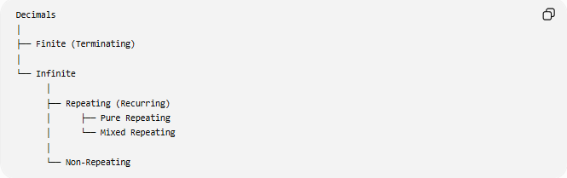
Decimals
│
├── Finite (Terminating)
│
└── Infinite
│
├── Repeating (Recurring)
│ ├── Pure Repeating
│ └── Mixed Repeating
│
└── Non-Repeating

Summary Table
# Source: AI Source: Provided by: [Data Path: Persons Table -> ID Column: 1, Name_En Column: Motasem Essam] -> From: [ChatGPT] on [7/11/2026]
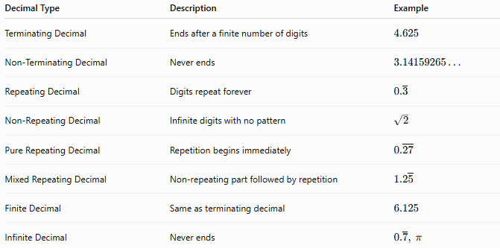
Decimal Type | Description | Example
Terminating Decimal | Ends after a finite number of digits | $$4.625$$
Non-Terminating Decimal | Never ends | $$3.14159265…$$
Repeating Decimal | Digits repeat forever | $$0.\overset{‾}{3}$$
Non-Repeating Decimal | Infinite digits with no pattern | $$\sqrt{2}$$
Pure Repeating Decimal | Repetition begins immediately | $$0.\overset{‾}{27}$$
Mixed Repeating Decimal | Non-repeating part followed by repetition | $$1.2\overset{‾}{5}$$
Finite Decimal | Same as terminating decimal | $$6.125$$
Infinite Decimal | Never ends | $$0.\overset{‾}{7}, π$$

Relationship with Number Sets
# Source: AI Source: Provided by: [Data Path: Persons Table -> ID Column: 1, Name_En Column: Motasem Essam] -> From: [ChatGPT] on [7/11/2026]
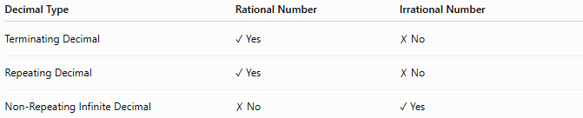
Decimal Type | Rational Number | Irrational Number
Terminating Decimal | ✓ Yes | ✗ No
Repeating Decimal | ✓ Yes | ✗ No
Non-Repeating Infinite Decimal | ✗ No | ✓ Yes

Real-Life Applications
# Source: AI Source: Provided by: [Data Path: Persons Table -> ID Column: 1, Name_En Column: Motasem Essam] -> From: [ChatGPT] on [7/11/2026]
Different types of decimals are used in:
- Money and banking
- Scientific measurements
- Engineering
- Statistics
- Computer programming
- Probability
- Physics
- Everyday calculations

Real-Life Examples
# Source: AI Source: Provided by: [Data Path: Persons Table -> ID Column: 1, Name_En Column: Motasem Essam] -> From: [ChatGPT] on [7/11/2026]
1. Money
A price of
$$19.95$$
is a terminating decimal.

2. Height Measurement
A person's height is
$$1.82\text{ m}$$
This is a terminating decimal.

3. Scientific Calculations
The value of
$$π=3.141592653589793…$$
is a non-terminating, non-repeating decimal.

4. Square Root
The value
$$\sqrt{2}=1.41421356…$$
is a non-terminating, non-repeating decimal.

5. Fraction Conversion
The fraction
$$\frac{1}{3}$$
equals
$$0.\overset{‾}{3}$$
which is a repeating decimal.

6. Probability
The probability
$$\frac{2}{9}=0.\overset{‾}{2}$$
is a repeating decimal.

7. Currency Exchange
An exchange rate of
$$54.375$$
is a terminating decimal.

8. Engineering Design
Measurements such as
$$0.125\text{ mm}$$
are terminating decimals commonly used in manufacturing.

Common Mistakes
# Source: AI Source: Provided by: [Data Path: Persons Table -> ID Column: 1, Name_En Column: Motasem Essam] -> From: [ChatGPT] on [7/11/2026]
- Confusing terminating decimals with repeating decimals.
- Assuming every infinite decimal is irrational.
- Forgetting that repeating decimals are rational numbers.
- Confusing pure repeating with mixed repeating decimals.
- Believing all decimal numbers have a finite number of digits.

Key Points
# Source: AI Source: Provided by: [Data Path: Persons Table -> ID Column: 1, Name_En Column: Motasem Essam] -> From: [ChatGPT] on [7/11/2026]
- Decimals are classified by whether they terminate or continue infinitely.
- Terminating decimals have a finite number of decimal places.
- Repeating decimals repeat one or more digits forever.
- Non-repeating decimals never repeat and represent irrational numbers.
- Pure repeating decimals begin repeating immediately after the decimal point.
- Mixed repeating decimals begin with non-repeating digits before the repeating pattern.
- Every terminating or repeating decimal is a rational number.
- Every non-terminating, non-repeating decimal is an irrational number.

Comparison of Decimal Types
# Source: AI Source: Provided by: [Data Path: Persons Table -> ID Column: 1, Name_En Column: Motasem Essam] -> From: [ChatGPT] on [7/11/2026]
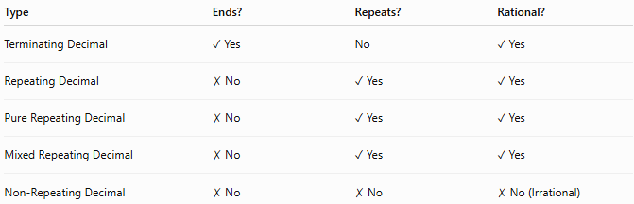
Type | Ends? | Repeats? | Rational?
Terminating Decimal | ✓ Yes | No | ✓ Yes
Repeating Decimal | ✗ No | ✓ Yes | ✓ Yes
Pure Repeating Decimal | ✗ No | ✓ Yes | ✓ Yes
Mixed Repeating Decimal | ✗ No | ✓ Yes | ✓ Yes
Non-Repeating Decimal | ✗ No | ✗ No | ✗ No (Irrational)

Conclusion
# Source: AI Source: Provided by: [Data Path: Persons Table -> ID Column: 1, Name_En Column: Motasem Essam] -> From: [ChatGPT] on [7/11/2026]
Decimals are numbers written using a decimal point and can be classified according to the behavior of their decimal expansion. The main types include terminating decimals, non-terminating decimals, repeating (recurring) decimals, non-repeating decimals, pure repeating decimals, mixed repeating decimals, finite decimals, and infinite decimals. Understanding these classifications is essential for working with fractions, rational and irrational numbers, measurements, and real-world mathematical applications.

3. Percentage
# Source: AI Source: Provided by: [Data Path: Persons Table -> ID Column: 1, Name_En Column: Motasem Essam] -> From: [ChatGPT] on [7/11/2026]
A percentage represents a part of a whole as a number out of 100.

Definition
# Source: AI Source: Provided by: [Data Path: Persons Table -> ID Column: 1, Name_En Column: Motasem Essam] -> From: [ChatGPT] on [7/11/2026]
The percent symbol (%) means "per hundred."

Example
# Source: AI Source: Provided by: [Data Path: Persons Table -> ID Column: 1, Name_En Column: Motasem Essam] -> From: [ChatGPT] on [7/11/2026]
75%
means
75/100

Equivalent Representations
# Source: AI Source: Provided by: [Data Path: Persons Table -> ID Column: 1, Name_En Column: Motasem Essam] -> From: [ChatGPT] on [7/11/2026]
The same quantity can be written in different forms.
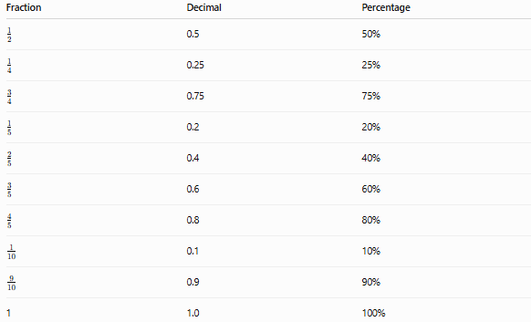
Fraction | Decimal | Percentage
1/2 | 0.5 | 50%
1/4 | 0.25 | 25%
3/4 | 0.75 | 75%
1/5 | 0.2 | 20%
2/5 | 0.4 | 40%
3/5 | 0.6 | 60%
4/5 | 0.8 | 80%
1/10 | 0.1 | 10%
9/10 | 0.9 | 90%
1 | 1.0 | 100%

Converting Between Forms

Fraction → Decimal
# Source: AI Source: Provided by: [Data Path: Persons Table -> ID Column: 1, Name_En Column: Motasem Essam] -> From: [ChatGPT] on [7/11/2026]
Divide the numerator by the denominator.
Example:
3/4​=3÷4=0.75

Decimal → Fraction
# Source: AI Source: Provided by: [Data Path: Persons Table -> ID Column: 1, Name_En Column: Motasem Essam] -> From: [ChatGPT] on [7/11/2026]
Write the decimal over the appropriate power of 10 and simplify.
Example:
0.6=6/10=3/5

Fraction → Percentage
# Source: AI Source: Provided by: [Data Path: Persons Table -> ID Column: 1, Name_En Column: Motasem Essam] -> From: [ChatGPT] on [7/11/2026]
Multiply by 100%.
Example:
1/4​×100%=25%

Percentage → Decimal
# Source: AI Source: Provided by: [Data Path: Persons Table -> ID Column: 1, Name_En Column: Motasem Essam] -> From: [ChatGPT] on [7/11/2026]
Divide by 100.
Example:
45%=0.45

Decimal → Percentage
# Source: AI Source: Provided by: [Data Path: Persons Table -> ID Column: 1, Name_En Column: Motasem Essam] -> From: [ChatGPT] on [7/11/2026]
Multiply by 100%.
Example:
0.82=82%

Percentage → Fraction
# Source: AI Source: Provided by: [Data Path: Persons Table -> ID Column: 1, Name_En Column: Motasem Essam] -> From: [ChatGPT] on [7/11/2026]
Write the percentage over 100 and simplify.
Example:
60%=60/100​=3/5​

Examples
# Source: AI Source: Provided by: [Data Path: Persons Table -> ID Column: 1, Name_En Column: Motasem Essam] -> From: [ChatGPT] on [7/11/2026]
○ Example 1
A chocolate bar is divided into 10 equal pieces.
You eat 3 pieces.
Fraction:
3/10
Decimal:
0.3
Percentage:
30%

○ Example 2
A student answers 18 out of 20 questions correctly.
Fraction:
18/20 = 9/10
Decimal:
0.9
Percentage:
90%

○ Example 3
Convert
5/8
Decimal:
0.625
Percentage:
62.5%

Visual Interpretation
# Source: AI Source: Provided by: [Data Path: Persons Table -> ID Column: 1, Name_En Column: Motasem Essam] -> From: [ChatGPT] on [7/11/2026]
Suppose a rectangle is divided into four equal parts.
If three parts are shaded:
Fraction:
3/4
Decimal:
0.75
Percentage:
75%
All three representations describe the same portion of the rectangle.

Real-Life Examples
# Source: AI Source: Provided by: [Data Path: Persons Table -> ID Column: 1, Name_En Column: Motasem Essam] -> From: [ChatGPT] on [7/11/2026]
1. Shopping
A store offers a 25% discount.
This means
25%=1/4=0.25
of the original price is deducted.

2. School Grades
A student scores
45 out of 50
Fraction:
45/50 = 9/10
Decimal:
0.9
Percentage:
90%

3. Money
If you spend half of your savings:
Fraction:
1/2
Decimal:
0.5
Percentage:
50%

4. Battery Level
A battery showing 80% charge means:
Decimal:
0.8
Fraction:
4/5

5. Weather
A forecast predicts a 40% chance of rain.
This is equivalent to:
0.4=2/5

Applications
# Source: AI Source: Provided by: [Data Path: Persons Table -> ID Column: 1, Name_En Column: Motasem Essam] -> From: [ChatGPT] on [7/11/2026]
Fractions, decimals, and percentages are used in:
- Arithmetic
- Measurement
- Finance
- Banking
- Statistics
- Probability
- Science
- Engineering
- Business
- Everyday calculations

Summary Table
# Source: AI Source: Provided by: [Data Path: Persons Table -> ID Column: 1, Name_En Column: Motasem Essam] -> From: [ChatGPT] on [7/11/2026]
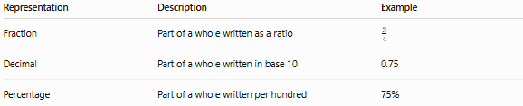
Representation | Description | Example
Fraction | Part of a whole written as a ratio | (\frac34)
Decimal | Part of a whole written in base 10 | 0.75
Percentage | Part of a whole written per hundred | 75%

Common Equivalent Values
# Source: AI Source: Provided by: [Data Path: Persons Table -> ID Column: 1, Name_En Column: Motasem Essam] -> From: [ChatGPT] on [7/11/2026]
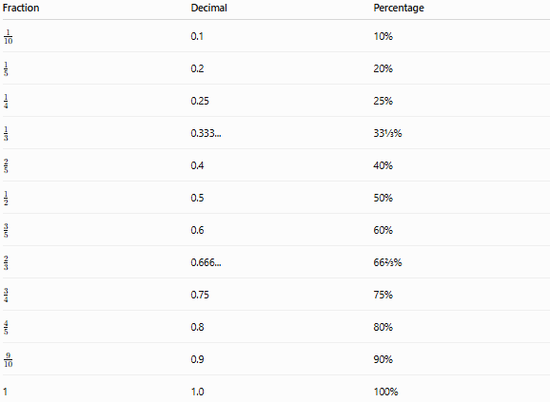
Fraction | Decimal | Percentage
(\frac1{10}) | 0.1 | 10%
(\frac15) | 0.2 | 20%
(\frac14) | 0.25 | 25%
(\frac13) | 0.333... | 33⅓%
(\frac25) | 0.4 | 40%
(\frac12) | 0.5 | 50%
(\frac35) | 0.6 | 60%
(\frac23) | 0.666... | 66⅔%
(\frac34) | 0.75 | 75%
(\frac45) | 0.8 | 80%
(\frac9{10}) | 0.9 | 90%
1 | 1.0 | 100%

Conclusion
# Source: AI Source: Provided by: [Data Path: Persons Table -> ID Column: 1, Name_En Column: Motasem Essam] -> From: [ChatGPT] on [7/11/2026]
A part of a whole can be represented as a fraction, decimal, or percentage. These three forms are equivalent ways of expressing the same value and can be converted easily from one form to another. Understanding these representations is fundamental to arithmetic and many practical applications in everyday life.

Memory Tip
Remember the relationship:
Fraction <-> Decimal <-> Percentage
For example:
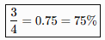
3/4 = 0.75 = 75%
All three expressions represent the same part of a whole.

